MSCI217 Group Report
By:
Jaheen Mohammad Jerry (38498472)
Michal Kosnik (38802139)
Dataset: 14-V

Table of Contents
Executive Summary 2
Introduction 2
1) Data Exploration and Time Series Decomposition 3
2) Questions for the Company 5
3) Forecasting Method Selection and Application 6
4) Forecast Evaluation and Error Analysis 6
5) Interpretation of Results and Model Selection 7
6) Discussion, Recommendations, and Conclusion 10
Conclusion: 10
Bibliography: 11

Executive Summary
This report comprises a comprehensive analysis of sales data of four products P1, P2, P3 and P4. For P1 and P2 the sales data are weekly and the products P3 and P4 are monthly and could be related. The main focus of this report is to apply and evaluate different forecasting models to improve the accuracy of sales predictions, which are essential for strategic planning and operational adjustments within the company.

Key Findings:
Product P1- It consistently sold well throughout the year without any ups and downs making it a great fit, for Simple Exponential Smoothing (SES). The model was quite accurate. Had forecasting errors showing stable sales trends.
Product P2- It exhibited a trajectory with very little seasonal variation, which Linear Exponential Smoothing (LES) could effectively capture. While short term predictions were on point long term forecasts might need adjustments.
Product P3; After analysis we found that the ARIMA (SARIMA) model was the effective choice as it could handle seasonal variations and detect a subtle upward trend. SARIMA accurately monitored growth trends and seasonal peaks.
Product P4; Forecasting, for this product posed a challenge because it lacked trends or seasonal patterns despite displaying some volatility. It might be necessary to wait for more data to identify patterns before considering using an SES approach.

Recommendations:
Regularly oversee and adjust the models to maintain their accuracy and relevance, for products with characteristics, such as P3 and P2.
Align inventory and marketing strategies with expected sales peaks for items, like P3 to improve resource allocation and maximise revenue opportunities.
Consider delving into advanced analytical methods or external market insights to enrich the predictive models for P4, where conventional approaches have faced challenges in identifying distinct trends.
This document highlights the significance of customised forecasting strategies for product categories. Offers guidance, on utilising statistical models to shape business decisions. It is recommended to update and recalibrate the models to adapt to evolving market dynamics and internal factors.

Introduction
This report was created as part of an internship project to enhance the company's sales forecasting methods through an analysis of sales data. The study focuses on four products. P1, P2, P3 and P4. Each exhibiting its sales trends. Sales figures, for products P1 and P2 are available up to November 12 2023 while monthly sales data for products P3 and P4 is provided until August 2023. Additionally the dataset for product P4 includes pricing information that adds depth to the analysis. The primary objective of this report is to apply time series analysis and forecasting techniques to unveil patterns and improve the accuracy of sales predictions. Through data exploration methods and time series decomposition this report aims to identify patterns in the sales data that can help in selecting forecasting models. The insights gained will not only enhance the company’s understanding of market dynamics but also refine forecasting strategies thereby aiding in informed decision making processes.

1) Data Exploration and Time Series Decomposition
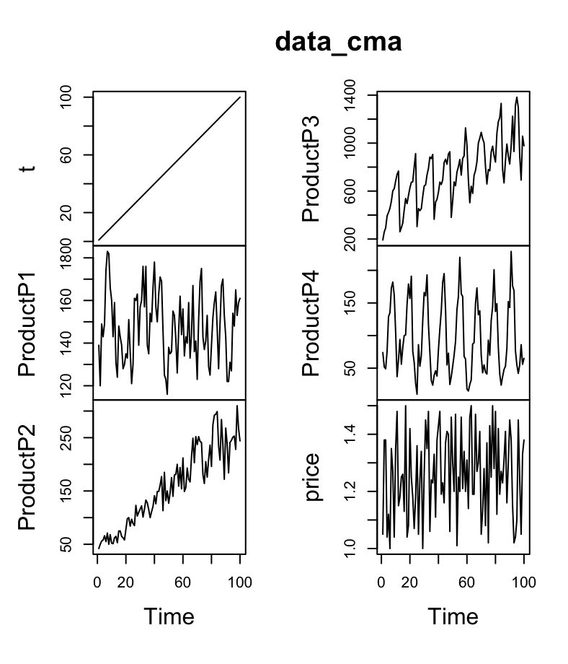
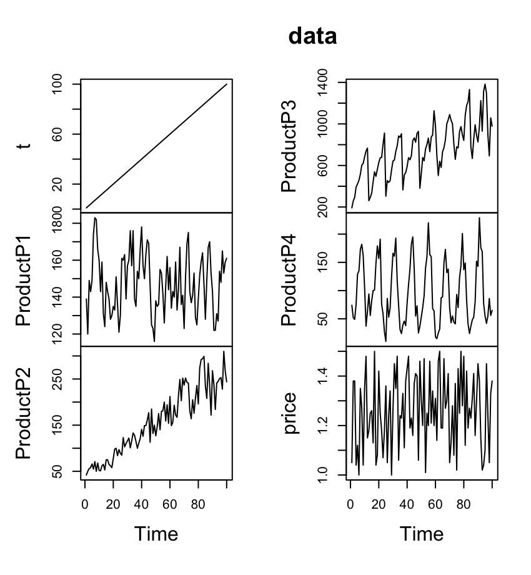
Time Series Data Overview and Centered Moving Average for all the products along with time, t and Average monthly price of Product P4, price
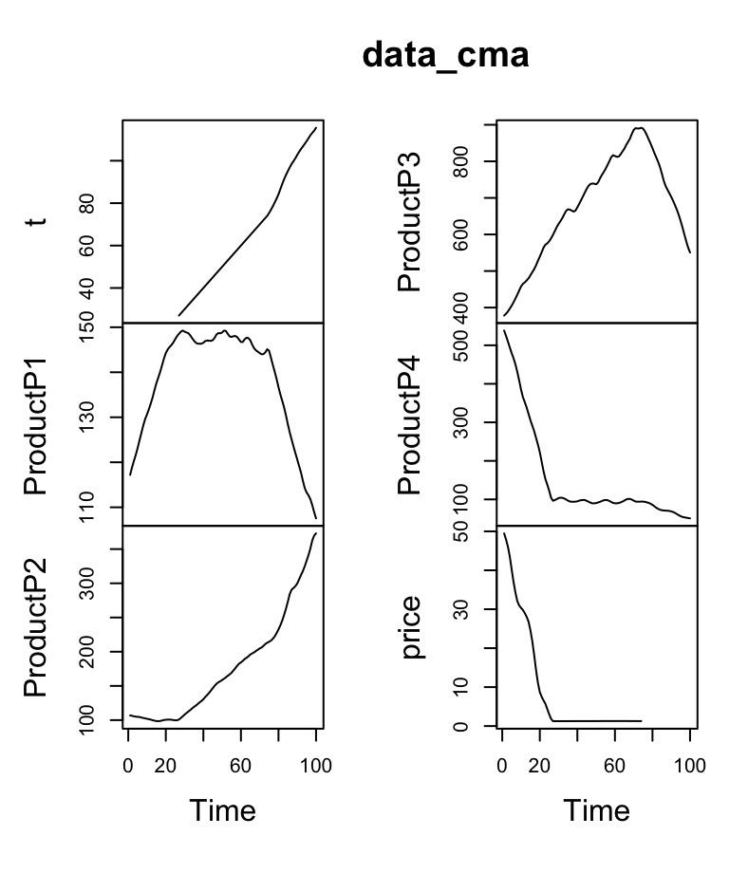
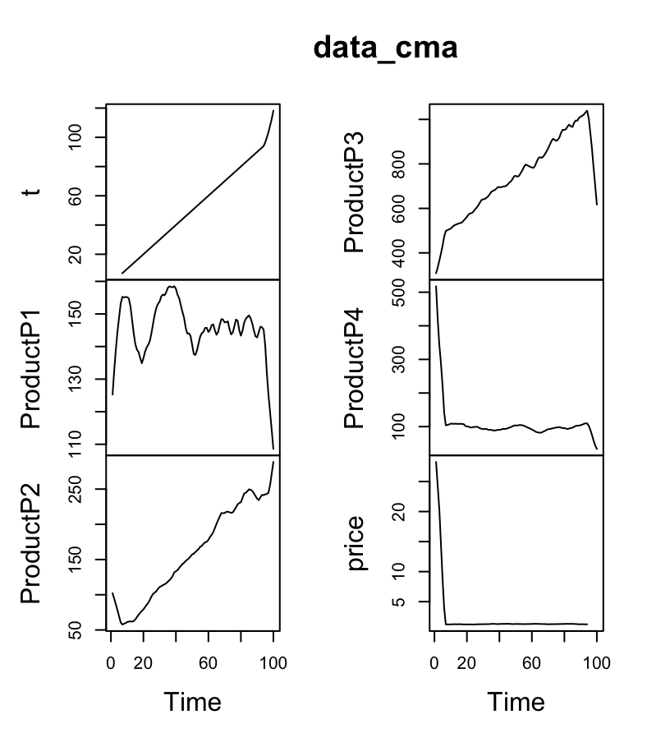
-CMA of all products for weekly and monthly intervals.

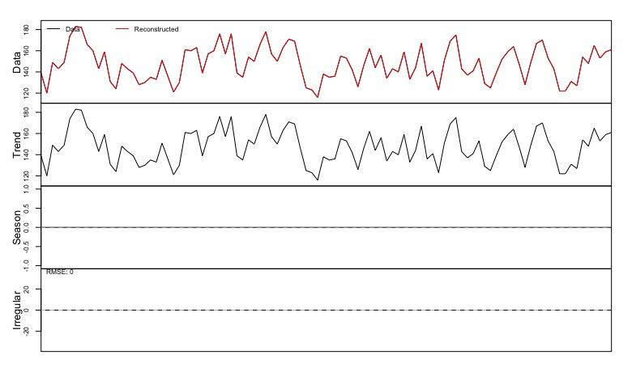 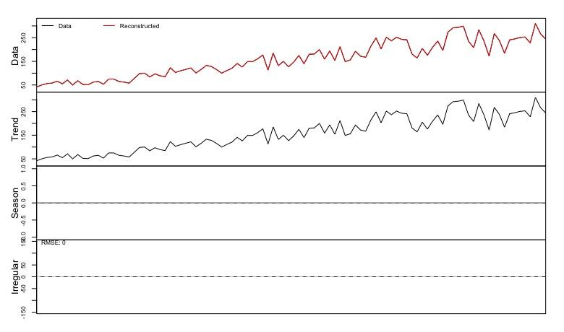
-Trend and Seasonality of P1 and P2
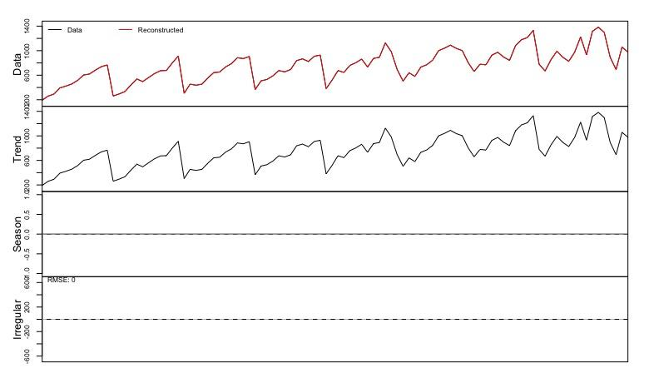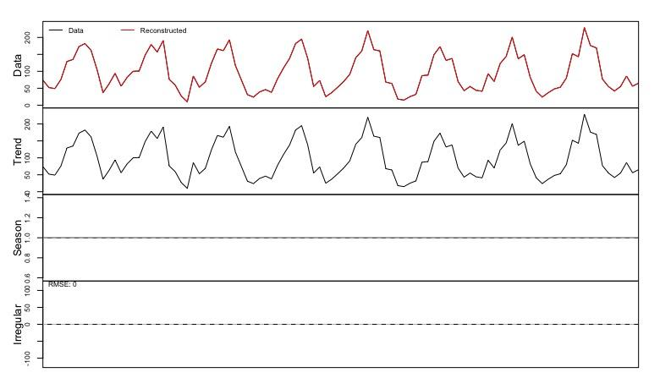-Trends and Seasonality of P3 and P4
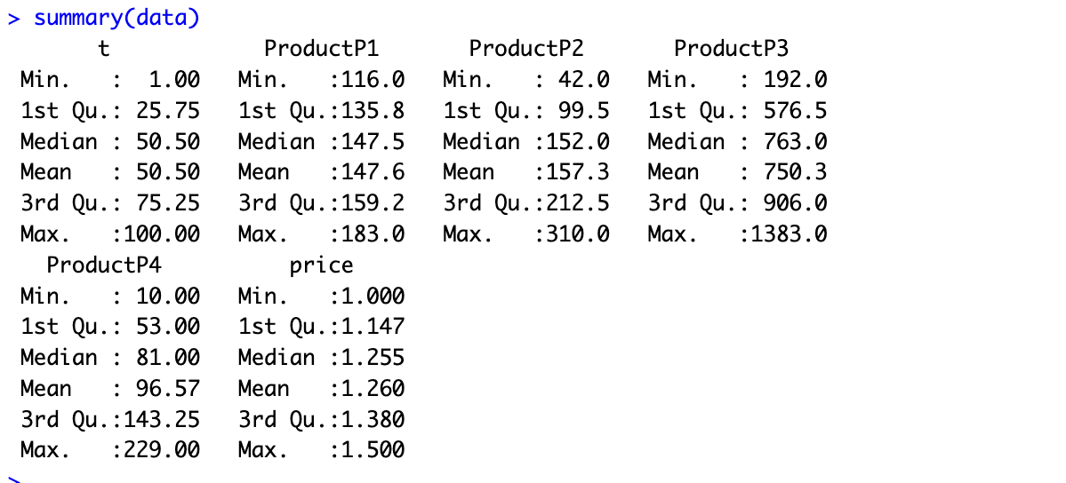
-Summary Table

Observing the data through visual aids like the plots extracted above, show that the product P1 has had stable sales with no apparent trend or seasonality, but cyclicity is present. Product P2 seems to have a consistent increase in demand, as shown by the gradual upward trend with no apparent seasonality. For products P3 and P4, the cyclicity is fairly evident given that the peaks and dips in demand are recurring at similar times of each period, however for P4, no apparent trend or seasonality can be determined, whereas a slight upward trend can be observed in the demand for P3 as the months progress, which hints at the possibility that P3 could be a service like electricity/energy with a rise in use during the end of the year perhaps because of winter, which would mean it has seasonality, although not completely obvious.
As the regular components, which is equal to Trend x seasonality, we subtract this from the data in order to get the errors, and when we subtract from the irregular decomposition, we can see a vector of zero that indicates it as a Mixed Multiplicative Model. Since P1 does not have an apparent trend, it may be best to use a simple average approach that assumes consistent sales and is probably the most suitable. P2’s upward trend can be smoothed out using Exponential Smoothing. Products P3 and P4 with both possible seasonalities and trends call for the use of Seasonal Arima (SARIMA) that can capture these dynamics.

2) Questions for the Company

Question ideas:
- How do marketing campaigns and promotions align with the sales spikes observed in the data?
Understanding the timing and impact of marketing actions could explain seasonal spikes, or anomalies in the sales for each product. This information would be crucial for incorporating external factors into the forecast model, potentially leading to a more accurate prediction
- Have there been any significant or unexpected changes in market conditions, consumer behaviour, or have there been any internal changes within the company, such as operational, product, etc?
Any of these factors would contribute to changes in the data,
- External Factors for P4: Are there external factors (e.g., competitor activity, economic changes) that might affect P4 sales besides price? Considering external influences can improve the robustness of forecasts for P4.

Reasoning:
The first question helps us get to know whether the spikes in the data has anything to do with promotional marketing campaigns and if so we can take it out of consideration and use the natural sales data to create a more reliable forecast. Understanding how the promotional campaigns come in to play can also help us potentially model these affects into our forecasts and create more accurate results. The second question regarding unexpected market conditions helps us understand the reasons behind market fluctuations and how customers behave which may potentially explain unexpected trends in the dataset. Other factors such as manufacturing issues, product modifications or other mishaps in production could also lead to these fluctuations, but getting to the root of the cause is crucial for us to make a more accurate forecast. The rationale behind the third and last question is that the data on the price of P4 is already available and understanding that external factors beyond price and internal company actions may have influenced the sales, it is also important for us to find out in order to incorporate it into our forecasting model. This helps us find out external factors that are not obvious in the data.

3) Forecasting Method Selection and Application

Even though fluctuations can be observed in the data plots of both P1 and P4, no clear upward or downward trend is observed over time. This makes these products the perfect candidates for Simple Exponential Smoothing (SES). Data that fluctuates around a central observable line is perfectly suitable for SES as it can effectively identify this pattern and use it for further forecasting. As P1 and P4 don’t have any obvious trends, relying mostly on historical data may not be the best decision as data from the distant past may no longer be relevant, especially for forecasting. SES focuses on current data from more recent sales that are likely to represent the current demand more accurately for these products. As both P2 and P3 exhibit obvious upward trends in sales, its most likely best to use a method like Linear Exponential Smoothing (LES) as it uses a weighted average of past observations, with more priority given to recent data like SES which allows it to adapt to changing trends in the data which is invaluable in identifying the upward trends in P2 and P3 sales. Being able to identify the influence of external promotional activities on sales makes SES particularly useful as it can adapt to recent changes quite swiftly assuming the changes are reflected in the most recent data points. If marketing campaigns and promotional effects are temporary and scattered, SES is sensitive enough to observe immediate post-promotion sales levels with great accuracy. This makes the first question chosen to be asked to the company regarding the impact of marketing and promotions, align perfectly with choosing SES for P1 and P4. Knowing about any significant shifts in market dynamics or internal operations will allow for more precise tuning of the trend smoothing coefficients for P2 and P3 giving more accurate forecasts. The question regarding unexpected market conditions and consumer behaviour is important for understanding the internal and external factors that come into play so the adjusting of the smoothing parameters of LES can be shifted accordingly.
Strengths:
SES excels at capturing stable patterns and focuses on recent data.
LES incorporates trends into forecasts and adapts to changing patterns.

Weakness:
SES has a limited capability when it comes to handling trends and its not the most ideal model for data with strong seasonality.

4) Forecast Evaluation and Error Analysis

Simple Exponential Smoothing (SES) highlights the significance of data suggesting that a good method to divide the data into training and testing sets is, by using most of the data for training and setting aside a portion for testing. A common practice in time series forecasting involves allocating 80% of the data for training and 20% for testing. To determine the in sample and out of sample settings for P1 and P4 we will employ an origin evaluation. For P2 and P3 Linear Exponential Smoothing (LES) is utilised, requiring an out of sample period to effectively assess its ability to capture trends. Initially we will use the 30-40 weeks/months of available data as out of sample to test the model. Like with products we will also utilise origin evaluation to identify the ideal in sample and out of sample configurations.

For error measurement on P1 and P4 Mean Absolute Error (MAE) was selected for Simple Exponential Smoothing (SES) focusing on data that are less influenced by outliers. MAE provides a magnitude of error without regard to its direction (positive/ negative).This approach is helpful, for SES because it focuses on data without compromising the models accuracy due to significant deviations that could be outliers. Additionally when using Linear Exponential Smoothing (LES) for P2 and P3 Mean Squared Error (MSE) is used to assess the error since it captures trends and punishes errors. Moreover MSE calculates the average of errors giving importance to significant deviations. This complements LES as accurately maintaining the trend is crucial for P2 and P3 with deviations posing a greater challenge, for precise forecasting.

5) Interpretation of Results and Model Selection
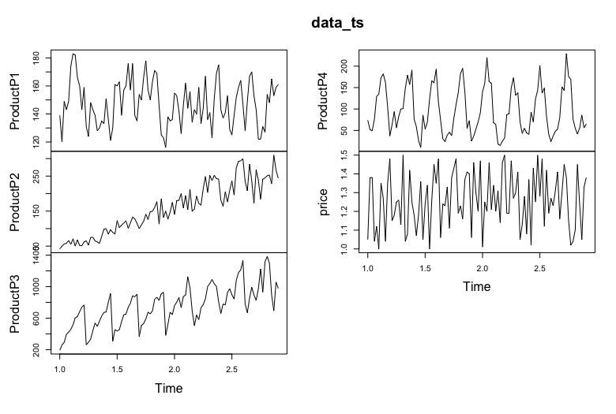
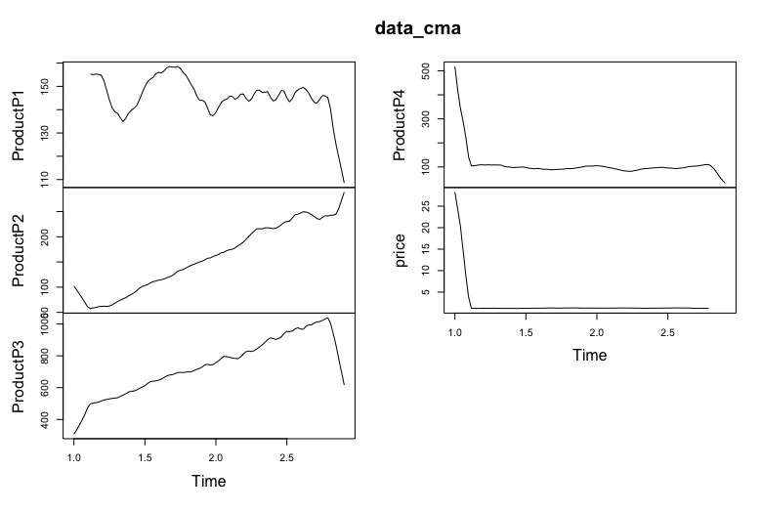

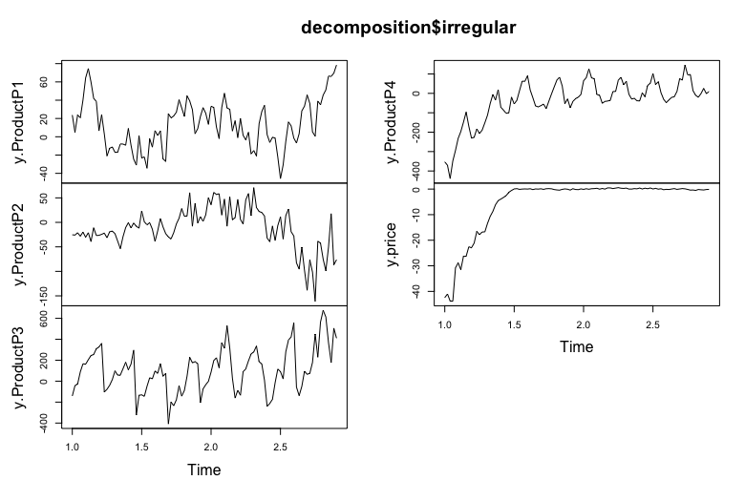

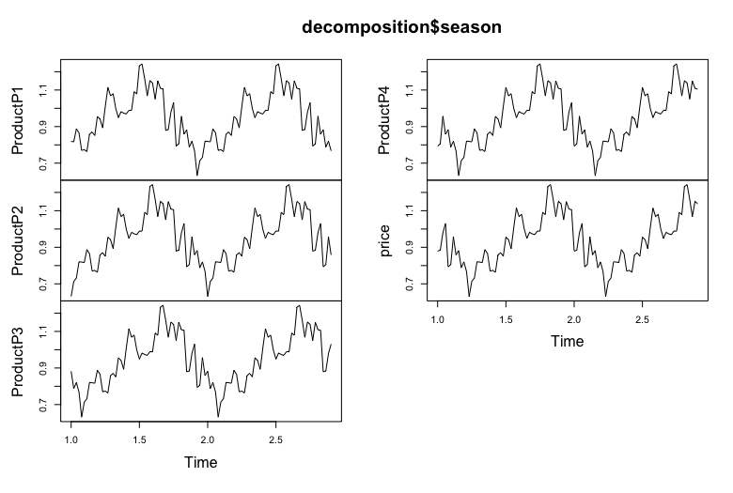

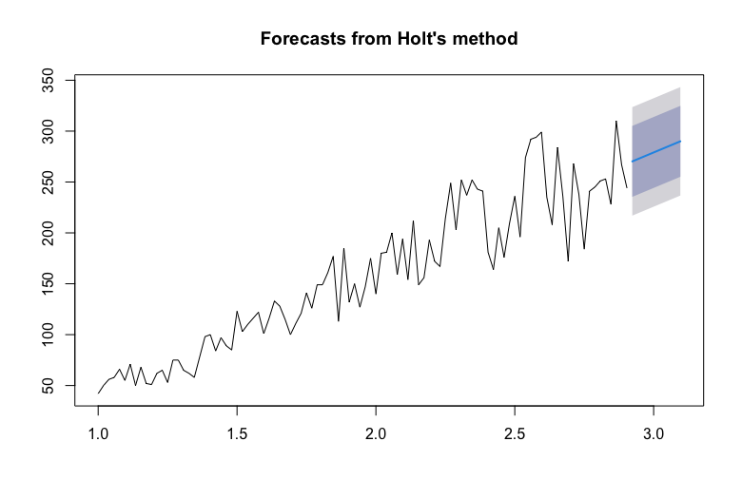
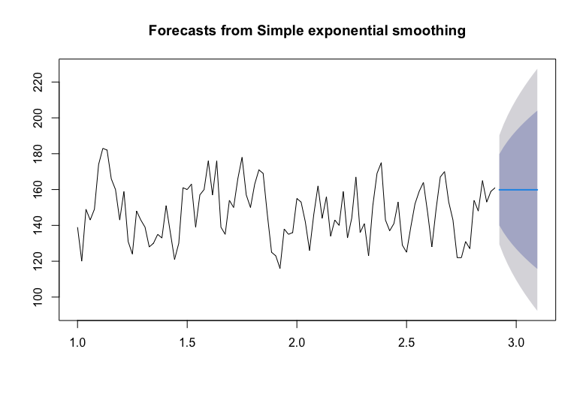

Analysing Applications and Forecasts:
For Products P1 and P4 we applied SES considering the pattern seen in the Data CMA plot. To evaluate forecast accuracy we looked at MAE and MSE focusing more on sales data where SES performed well.
Product P2 underwent LES (Holt’s Linear Exponential Smoothing), due to its trend in the Data CMA plot. We assessed LESs capability to handle trends through 1 step and 5 step forecasts. The results were visually depicted in Holts Method plot showcasing the models abilities and adaptability to trends.
Product P3 exhibited fluctuations in the Decomposition Season plot making SARIMA a choice. We evaluated SARIMA models for their effectiveness in integrating nonseasonal variations.
Error metrics (MAE MSE) emphasise that SES delivers forecasts for products like P1 and P4 while LES suits products with clear trends like P2 better. SARIMA efficiently addressed the elements of P3 as indicated by error rates across various forecasts.

Adjusting Models:
Based on error metrics and visual analysis from plots it is recommended to consider adjustments to the models. In the case of P2 tweaking the settings of LES might help minimise the forecast inaccuracies that tend to occur in longer forecasting periods. As for P3 tuning SARIMA parameters could enhance precision particularly when capturing peak demands.

6) Discussion, Recommendations, and Conclusion

The SES model demonstrated robustness for stable sales environments as seen in P1 and P4. LES’s performance for P2 is strong in the short term, however requires recalibration for better long-term accuracy. SARIMA’s robustness was evident across both short and long-term forecasts for P3 and effectively manages the seasonal variations.

Performance Variations:
The differences, in performance can mostly be attributed to how each model dealt with the characteristics of the dataset. SES works best in scenarios without trends or seasonality limiting its effectiveness due to its simplicity. LES is adept at handling trends. May require adjustments for long term forecasting due to its capability to capture linear patterns. SARIMA demonstrated performance by managing both trends and seasonal variations.

Suggestions;
for P2 exploring advanced models capable of accommodating non linear trends could be beneficial. Based on the forecast findings it is advisable for the company to align its inventory and marketing strategies with the projected demand cycles for products like P3.

Ongoing Monitoring; Establish a system for monitoring and recalibration of models to adapt to evolving market conditions and internal changes within the organisation.

Conclusion:
After analysing the sales data of products P1, P2, P3 and P4, we have gained valuable insights into the sales patterns. This has helped us improve our forecasting accuracy and strategic planning.

Key Discoveries:
Product P1 remains stable and is well suited for Simple Exponential Smoothing.
Product P2 shows an trend making it suitable for Linear Exponential Smoothing.
Products P3 and P4 present complexities; while Seasonal ARIMA is recommended for P3, refining strategies is advised for P4 due to pricing influences.

Strategic Suggestions:
Enhance Forecasting Models; Stay updated with market changes by adjusting forecasting techniques.
Make sure you're managing your inventory and pricing effectively by using forecast insights to adjust inventory levels and pricing strategies based on trends. Coordinate your marketing efforts, with demand forecasts to make the impact. Looking ahead consider investing in analytics to enhance accuracy and model reliability. By refining these models you can boost efficiency. Respond quickly to market changes.

Bibliography:
Part I: Principles of business forecasting: A first course in forecasting (no date) Wessex Press Publishing Co. Available at: https://wessexlearning.com/products/principles-of-business-forecasting-2nd-ed-part-i (Accessed: 22 April 2024).

